Bulgarian Diploma Thesis

AI Dungeons and Dragons

Yane Yanev,

Supervisor: Antonin Stoilov

Department of Computer Science, AUBG Blagoevgrad, 2025

Title: AI Dungeons and Dragons

Author: Yane Yanev

Abstract: This COS project focuses on giving users the ability to play the popular game of “Dungeons and Dragons” by themselves without any complex requirements. This application named “AI Dungeons and Dragons” is an interactive chatbot created mainly with Java that leverages advanced artificial intelligence (AI) technologies to simulate real one to one Dungeons and Dragons sessions, providing the users the opportunity to enjoy a fun experience with dynamic action and feedback.

Declaration of authorship:
“The Senior Project/Bulgarian Diploma Thesis presented here is the work of the author solely, without any external help, under the supervision of Anton Stoilov. All sources, used in development, are cited in the text and in the Reference section.”

Author: Yane Yanev

0.Table of Contents

0.Table of Contents 3
1. Introduction: 4
2. Specification of the Software Requirements and their Analysis 6
2.1 Functional Requirements: 6
2.2 Non-functional Requirements: 10
2.3 UML Case Diagrams 12
2.4 Activity Diagram 14
2.5 Technical Architecture 14
2.6 Significance and Innovation 15
2.8 Future Development Potential: 17
3. Design of the software solution 18
3.1 Software Architecture 18
3.2 Special Algorithms and Technical implementations 19
3.3 User Interface Design 22
3.4 Software Components 23
3.5 UML Diagrams 25
3.6 Security Features and Reliability 26
4. Implementation 29
4.1 Technology Stack Overview 29
4.2 Installation Requirements 32
4.3 Interesting Implementation Features 33
5. Testing 36
5.2 Integration Testing 39
5.3 Acceptance Testing 39
5.4 Performance Testing 40
5.5 Security Testing 41
5.6 Test Coverage Report 42
6. Results and Conclusion 42
7. References 62

1. Introduction:

In today’s gaming and tabletop market there does not exist a good or accessible way to play Dungeons and Dragons by yourself. I believe this is a sufficiently lacking market that I wish to fill with my own work.

I believe many people in my generation are major fans of Dungeons and Dragons as a concept. This thrilling game of imagination and strategy has captivated people for decades and continues to do so till this day. But despite this rampant success of the tabletop game, it faces many limitations and challenges in actually taking part in a session. First of all, Dungeons and Dragons sessions require at the very minimum one other person, and at maximum enough people to fill a table. Anyone who has attempted to host a Dungeons and Dragons session will tell you that both finding and organizing such an event is a logistical nightmare to execute. Conflicting schedules, last minute issues, players dropping out, sickness and so on. By having the session be managed by an AI, it eliminates the need for other people to create a session. Another issue I wish to solve is the items needed for a session. Usually to make a session, you would require dozens of times from each player such as dice, character sheets, rulebooks, figurines, art of characters, maps for the dungeons and so on. By simplifying this process with AI, I am able to eliminate the need for items and complicated preparations needed for a session.

Modern Technology stack:
- Frontend: Latest version of React for optimal performance and development
- Backend: Spring Boot 3.5.6 for robust backend work.
- AI Integration: OpenAI’s ChatGPT for intelligent conversations and prompt generation
- Real-time Communication: WebSocket for seamless transfer of messages
- Database: MySQL 8.0 for reliable data persistence

Architecture and Design:
- Microservices architecture for scalability and maintainability
- Event driven design for real-time features

Core Features:

AI Powered Chat Interface:
- Real-time communication with an AI “Dungeon Master”
- Context-aware responses based on predetermined story settings
- Dynamic prompt history management
- Adaptive storytelling based on user responses

Session Management:
- Creation of a new DnD session through a modal interface
- Customizable character sheet for the session
- Persistent chat history for each session
- Easy access to previous sessions
User Authentication System:
- Secure user registration and login
- Session management and security

The motivation I had behind choosing this project was the observed gap in available tools to play Dungeons and Dragons as a single individual. Firstly, I wanted to address the market needs as there is very limited availability for actualized Dungeons and Dragons sessions either online or in real life, the latter bearing high costs in items and time for preparations. Secondly, I wanted to advance my technical knowledge because this kind of project allows me to implement and learn how to use real-time communication systems and explore modern web development practices, Lastly I wanted to have an enjoyable impact on users that will be using said project because it provides consistent high-quality Dungeons and Dragons sessions, and it offers data-driven freedom for expression. Many existing tools only focus on providing static experiences and choices, which do not adapt to the users playstyle or cater to any specific requirements they may have. I believe AI Dungeons and Dragons is the solution to this problem.

2. Specification of the Software Requirements and their Analysis

The AI Dungeons and Dragons (AIDnD for short) like any other application, needs a problem to be solved, a user to use the application to solve the problem and the solution to be provided in an easy, clear manner that the user can understand and use well. AIDnD as with any application, has software requirements that guide the development of the application so that the end product can satisfy the requirements of the users.

I will be describing all of the functional and non-functional requirements, along with the details and analysis of each one. However, as with any product, the functional and non functional requirements are the ideal outcomes, they might not be implemented as perfectly as described here. I will strive to make the most important details and decisions complete, ensuring that the application will ork properly so as to have a successful product.

2.1 Functional Requirements:

FR1: DnD session management
- FR1.1: Users must be able to create a new DnD session.
- FR1.2: Users must be able to create their own character sheet.
- FR1.3: Users must be able to save the current session in a “save file”
- FR1.4: Users must be able to see all of the saved sessions they have
- FR1.5: Users must be able to resume their saved sessions

FR1: Analysis
Create new DnD Session:
1. User clicks “new session” button.
2. System displays a form with fields:
a. Name
b. Age
c. Level
d. Species
e. Background
f. Strength
g. Dexterity
h. Intelligence
i. Constitution
j. Wisdom
k. Charisma
3. User fills details and saves
4. System:
a. Creates a new session
b. Links session to user
c. Initializes empty chat history
d. Configures the AI with provided details

Save Sessions:
1. Click on save session button
2. System saves the chat session in a file
3. System displays a popup with:
a. message of failed or successful save
b. button to exit to main menu
4. User exits to main menu or continues chatting
Access saved sessions:
1. Click on load sessions button
2. System displays saved sessions with:
a. Character name
b. Character level
3. User selects session
4. System loads:
a. Complete chat history
b. DnD session context
c. AI configuration

FR2: AI Chat
- FR2.1: System must process user actions
- FR2.2: System must generate contextually relevant responses
- FR2.3: System must provide DnD sessions specific story
- FR2.4: System must provide DnD sessions specific action responses
- FR2.5: System must process multiple conversation turns

FR2: Analysis
Chat interaction flow:
1. AI shows initial story context
2. User sends a message
3. System:
a. Saves message
b. Prepares context:
i. Previous messages
ii. Character details
iii. Saved message
3. Call OpenAI with:
a. System prompt (session context)
b. User message
c. Chat history
4. Process API response:
a. Format content
b. Handle errors
5. Save response
6. Return formatted response to user

2.2 Non-functional Requirements:

NFR1: Performance
- Response time for AI must be fast
- System must handle users efficiently
- Session history must be loaded quickly
- UI must be responsive during API calls

NFR1 Implementation approach:
1.Implement client-side catching:
- Cache chat histories
- Cache user session data
- Cache replies
2.Optimize API calls:
- Debounce user inputs
- Implement request queuing
- Use WebSocket for real-time updates
3.Database optimization:
- Index frequently queried fields
- Implement pagination for chat history
- Use connection pooling

NFR2: Scalability
- System must handle growing number of users
- AI must maintain performance over bigger load
- Save system must be able to accommodate large number of saves
NFR2 Implementation approach:
Scalability strategy:
1.Database design:
a. Implement sharding for chat histories
b. Use read replicas for heavy queries
c. Archive old chat data
2.Application architecture:
a. Implement microservices
b. Use load balancing
c. Configure auto scaling
3.Resource optimization:
a. Implement caching layers
b. Optimize database queries
c. Use connection pooling
NFR3: Security
- All communication must be encrypted using HTTPS
- Passwords must be stored with secure hashing
- API endpoints must be secured against unauthorized access

NFR3 Implementation approach:
Security implementation:
1.Authentication:
- Use BCrypt for password hashing
2.Authorization checks:
a. Check user permissions
b. Implement rate limiting
3.Data protection:
a. Sanitize user inputs
b. Encrypt sensitive data

2.3 UML Case Diagrams

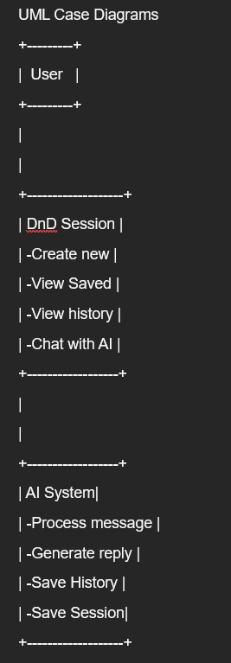
Figure 1 UML Case Diagram

2.4 Activity Diagram
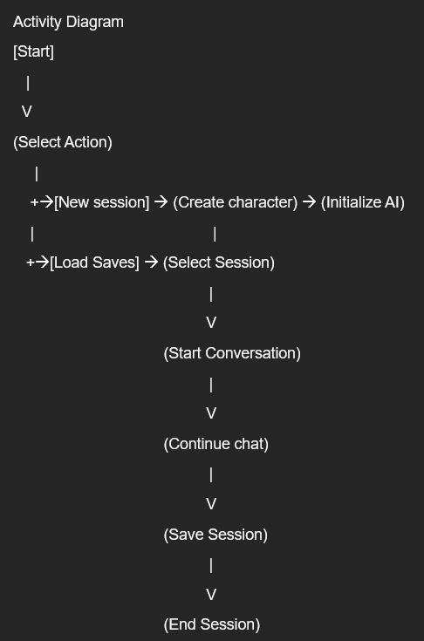
Figure 2 Activity Diagram

2.5 Technical Architecture

Frontend Technology

Core Technologies:
- React
- Tailwind CSS

Backend Technology

Core:
- Spring Boot
- Java 17
- Maven
- MySQL database

Security and Authentication:
- Spring Security
- BCrypt password encryption

API Integration:
- OpenAI API integration for responses
- Websocket for real time communication

2.6 Significance and Innovation

This project is a step in the right direction for integrating AI into videogames and websites in order to bring about innovation and accessibility. Several aspects of this project make it interesting for a consumer:
Accessibility and Convenience:
- Users can play anytime anywhere
- No need for human partners to play
- Immediate feedback and storytelling
- Persistent saves for long term enjoyment

Personalization:
- Conversation adapts to the users’ actions
- Custom character sheet
- Context aware responses

Modern Architecture:
- Fullstack JavaScript/Java implementation
- Real-time communication
- Scalable codebase

Practical Design:
- Easy to access save files
- Clean UI with minimal design
- Clear display of information

2.7 Technical Challenges and Solutions
Real-Time Communication:
- Implemented WebSocket for instant message delivery
- Handled connection stability and reconnect logic
AI integration:
- Integrated OpenAI API for creative and intelligent responses
- Managed conversation history and character context
- Optimized API usage for cost-effectiveness
- Implemented error handling and fallback

Security Implementation:
- Protected API endpoints
- Secure password workflow

2.8 Future Development Potential:

While the current app itself is a solid execution of the intended idea, there are a lot of features that can be added to fully delve into the topic:
Feature expansions:
- AI voiceover for both users and AI responses
- Ability to house multiple users
- AI generated imagery for further storytelling
- More game mechanics from the tabletop game

Technical Improvements:
- Advanced AI model integration
- Better real-time capabilities
- Better error handling
- Better performance

This project showcases how AI can be used to enhance and realize very complex ideas that can not be handled by regular means. The combination of complex AI generated responses and infinite freedom for player expression results in an entertaining tool for those interested in playing Dungeons and Dragons.

3. Design of the software solution

The software design of the AIDnD chatbot applications that I have created is focused on maintaining a stable, fun and interactive user-friendly system. The core components of the system are the customizable character creator, that lets the user create their own character and background. Another core component is the interface for interactive dialogue and storytelling that provides feedback on the user’s choices and actions. The backend architecture was developed to support scalability, ensuring smooth performance as more people use the application, while the frontend is designed to prioritize clean, easy to use and intuitive interface so that the users can have seamless interactions, ensuring the complete experience of a DnD session.

3.1 Software Architecture

This application is created following the modern microservices architecture pattern, with clear separation of concerns. I implemented a Model-View-Controller (MVC) architecture in both frontend and backend components. The following are the main architectural components of the system:

Frontend Layer (View)
- Spring Boot based multi-page application
- API integration
- UI components
- Character Creation

Backend Layer (Controller)
- DnD Session management service
- AI integration
- Websocket Service
- Data Acess Layer

Database Layer
- File Storage/Access
- MySQL Database

3.2 Special Algorithms and Technical implementations

Binary Space Partitioning (BSP) Dungeon Generator
Binary Space Partitioning algorithm, or BSP for short, is an algorithm most commonly used in games to procedurally generate a dungeon layout for gameplay purposes. BSP first takes a large rectangular map, and the recursively splits it apart into different rooms. After the rooms are split apart, they are connected to each other and into a corridor of rooms. This algorithm is very efficient and creates very well organized, but still random grid structures for the environment. It also avoids the pitfall of making long skinny rooms and the like by having a depth limit to the recursive splitting.
At the heart of this algorithm is three different functions. The first function is the “splitRecursively” function, it takes a root room with its height and width and then recursively splits it into smaller rooms that each have a leaf and coordinates to indicate location. This splitting results in a fair number of rooms being created that will then become more varied with the next two functions. The second function is the “createRooms” function, it takes the leaf nodes and turns them into proper “rooms”. Each room has a position (x,y), width, height, and its own rectangle within the space. This function leaves some room as to avoid the rooms touching or overlapping with each other. The last function is the “connectRooms” function, it connects rooms by establishing paths and corridors between them. By doing this, we have created a complex maze of rooms that have randomized sizes, corridors and pathways.
The use for this algorithm is to create a complex dungeon for dungeon exploration within the AI DnD application. When the AI API is connected to the application though a WebSocket connection, this algorithm is run in order to give the API a structure to follow whenever the user enters a dungeon/cave system. It is done with the intention of making the AI provide a better experience, while also lessening the reliance on the AI for each and every task.
Here is the pseudo code for the algorithm:
function generateDungeon(mapWidth, mapHeight) {
root = new BSPNode(0, 0, mapWidth, mapHeight);
root.splitRecursively(maxDepth);
root.createRooms();
connectRooms(root);
return root;
}
OpenAI Handling Algorithm
This algorithm is at the heart of this project. It is the algorithm used every time a call for the API is done through the chat interface in the front end of the application. This algorithm first takes the string input, which is the user prompt made in the front end of the application, then it formats it in such a way that that it becomes eligible for the API to read and respond to the input. After the input has been formatted appropriately, the algorithm creates a request prompt by combining the formatted input and the parameters of the API, such as API version and content. Now that the request prompt is done, the algorithm creates a HTTP connection to the API, which routes the request prompt to the API. If this step fails, the algorithm handles the error and returns the error report to the front end of the application. If this step succeeds, then the algorithm starts to decipher the response json of the API. The response is structured in a very specific way, to the point where a single typo can create a cascading issue that makes the entire project stop working. When the response is parsed, the algorithm returns a single string object as a return statement, which is the real response of the API.
Here is the pseudocode for the algorithm:
public class CallOpenAIService {
function callOpenAiApi(input) {
formattedHistory = formatHistoryForOpenAI(input);
HttpEntity entity = new HttpEntity<>(request, headers);
ResponseEntity<Map> response = restTemplate.postForEntity(apiUrl, entity, Map.class);
Map responseBody = response.getBody();
parseResponse(responseBody);
}
Session History Management Algorithm
This algorithm is designed by creating a SessionHistory class designed to both store the session history of the chat, but also intelligently manage the contents of the history so that it remains within the constraints of the API model’s context window. This ensures that the total number of tokens (which means size of the content) does not exceed the limit allowed by the openAI API model. To account for the generation of the next response, a buffer is put in place to ensure that the next response will always be recorded. This buffer guarantees the space for the next incoming user input and the API’s reply
In the center of this class is the manageSessionHistory function. This function uses the list of past messages within a SessionHistory object, and the new incoming message as input. The method starts by initializing the session history with its fundamental elements: the starting system prompt, and the current session history. These are the fixed points that guide the behavior of the AI and set the rules for the session. After determining how many tokens the new message will consume, the algorithm calculates how many tokens remain from the maximum limit. Then by going through the messages in a backward manner (from newest to oldest) it selectively includes as many messages as possible without exceeding the allowed limit. This is done with the intention of prioritizing the recent messages that have more of an impact on the session, while discarding the older messages whenever necessary. When the token limit is reached, the loop ends and the final, trimmed session history is returned, ready to be passed to the AI API. Overall, this algorithm strikes the balance between memory allocation and necessary memory deletion to adhere to the APIs limitations.

3.3 User Interface Design

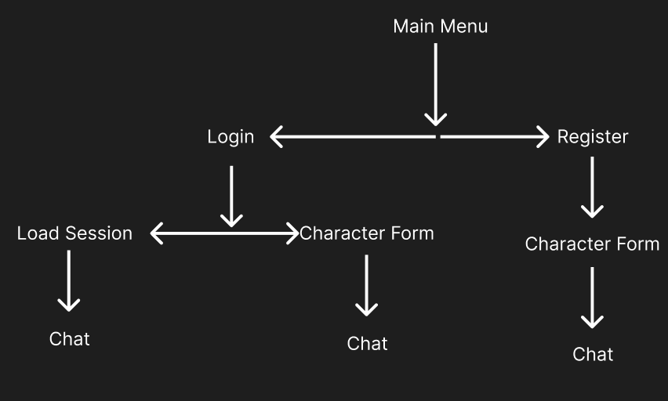
Figure 3 User Interface pattern

UI/UX Considerations:
- Responsive Design
- ARIA labels and keyboard navigation
- Error handling

3.4 Software Components

Frontend Components
Authentication Module
Interface AuthenticationModule {
Login(credentials): Promise<User>
Register(credentials): Promise<User>
}
Backend Components
Controller Layer
The MainController class serves as the controller layer of the MVC architecture. It is the entry point for requests related to DnD sessions. It routes the incoming calls to appropriate logic, which enables a clean separation of concerns between web and business operations.
Annotated with @Controller, this class is automatically detected by Spring Boot and exposed as a Controller service. The first end point defined using @PostMapping(“/AIDnD”), handles the requests to OpenAI to create new DnD Sessions. It expects information from a SessionRequest object which contains the necessary information inserted by the user to create a new session (examples: character name, age, level, background, species, stats and so on). After receiving the necessary information, the controller uses its logic to create a new DnD session.

Service Layer
The CallOpenAIService class represents the service layer, acting as a bridge between the controller layer (which handles HTTP requests) and the data access layer (which interacts with the database). It fully contains the business logic related to the DnD Sessions and ensures that the application is modular, testable, and easy to maintain.

Annotated with @Service, the class is marked as a Spring Boot service component, allowing it to be automatically discovered and injected wherever needed. The core method here is “callOpenAiApi” which is responsible for calling the API from openAI. It accepts a string as its input, and then processes that string into a working prompt for the API. Once the prompt is sent to the API in the form of a HTTP post, the service then parses the received object and returns a clean string.
Data Access Layer
The SessionRepository class represents the data access layer of the application and is responsible for storing and accessing data from “save files”. It is marked as a @Repository, which lets Spring Boot mark it as a component dedicated to data management. This class has a few functions that are vital to the overall functioning of the program. The first function is “storeData” which takes all of the data of a DnD sessions (chat history, character sheet) and stores them in a file format. The second function is “readData”, it reads the content of a chosen file and sends it to the MainController in order to create a new DnD session using existing information from the file. The last function is the “showData” function that stores and sends preliminary data to the MainController so that the user can pick and choose which file to open and resume the session of.
SessionRepository is the applications gateway for persistent, local storage for DnD sessions. It does not interact with the complexities of managing of databases or SQL commands, but instead uses local file storage to fulfill the needs of the program.

3.5 UML Diagrams
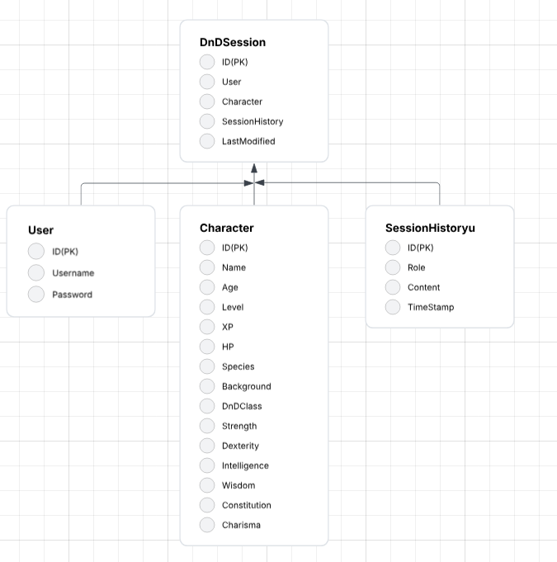
Figure 4 Database Tables Structure
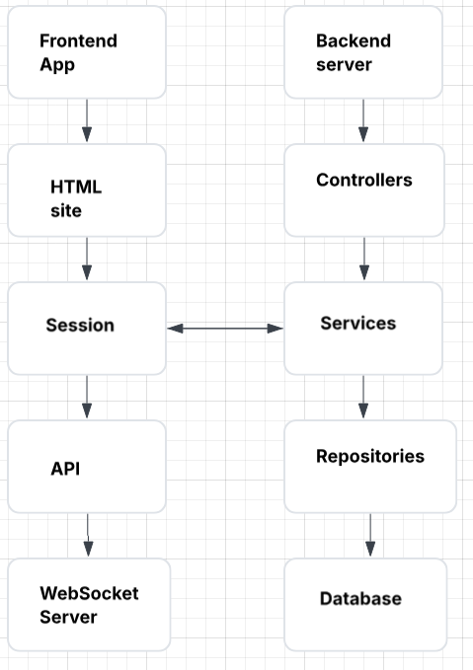
Figure 5 Front and Back end integration

3.6 Security Features and Reliability

Security Implementation
Authentication Security
The SecurityConfig class configures the security layer using Spring Security. It defines how authentication and authorization are handled throughout the system. The class is annotated with @Configuration, signaling to Spring that this is a configuration class and that it should activate Spring Security’s 31 web security features. It extends WebSecurityConfigurerAdapter, a convenient base class that allows developers to override specific methods to customize security behavior. (Note: As of Spring Security 5.7+, this approach is being deprecated in favor of component-based security configuration, but it's still valid in many current codebases.)
Password Security
- BCrypt hashing
- Failed login attempt limiting
- Minimum password requirements

API Security
- Rate limiting
- Input sanitization

Reliability Considerations
Error Handling
The ErrorHandler class forms the centralized strategy for managing multiple different errors that may occur in the application. This class was built to ensure that errors are handled consistently and efficiently, improving both the user and developer experience.
At the core of this class is the handleError method, it takes an Error object as input. The object most often includes metadata about the kind of error that occurred, possibly along with messages, code, or context of the error. It uses a switch statement to determine the cause and nature of the error based its typing, it then routes the error to the appropriate handler function.

Data Persistance
- Database backups
- Data validation
- Audit logging

High Availability
- Database replication
- Health monitoring
- Failover mechanisms

Performance optimization
- Database indexing
- Connection pooling
- Response caching

4. Implementation

The implementation part of the AIDnD project focuses on the practical application of designs while also showcasing the specifications outlined in the previous sections. I will now show a detailed overview of all the technology and external frameworks plus libraries that I used in this project. I will also be detailing the installation for the respective applications and the rationale behind some of the choices I made.

4.1 Technology Stack Overview

Java 17
The main point of choosing java as my programming language for this project was its stability, extensive libraries and strong typing system.
For Java 17 specifically, it is an LTS version, which means that it receives long-term stability updates, security patches and support for many years. This makes it a very reliable base for creating systems and applications where stability is very important.
JDK 17 has modern java features that simplify code, improve its readability, and enhances its performance. All of this while also having backwards compatibility with older Java versions. One of the biggest improvements over older versions is its performance, it has faster startup time, lower memory usage and improved compilation. Its LTS status also gives it the benefit of being more secure than other versions, receiving more recent security updates, better cryptography, stronger defaults, safer APIs and more.
Another important part of the choice to use Java 17 is that it is supported, and even preferred, in many modern frameworks such as Spring Boot and Maven that are utilized in this project. This is because Java 17 is seen as the “industry standard” version of Java, so companies choose it as a baseline for reliable and secure development.

MySQL
MySQL is a widely used relational database management system. It is used by many of the most well known companies in the world such as Netflix, Uber, Airbnb, Youtube and so on. It is an open source and free application, which makes it ideal for a project such as this.
The major reason for my choice of MySQL other than the fact that I have studied it in the university already, is that it is extremely well optimized. MySQL has little to no issues when it comes to latency, its join functions are remarkably fast, it has good query optimization and importantly, is very scalable.
MySQL is very easy to set up and utilize, resulting in short development time that can then be utilized on more important parts of the project. I personally use it with the application XAMPP, which only requires a few clicks to fully set up a MySQL database server. Another big reason for its utilization in this project is that it is very compatible with both Java and Spring Boot, which are the very foundation that my project is based on.
Finally, since it is an open source application with wide community support, there are many tools designed for it, such as performance monitoring, visual ER diagram creation, schema design tools and so on. This sort of support allows me to fully utilize MySQL without having to spend hours researching the perfect solution to my needs.

Spring Boot
Spring Boot was chosen as the main framework for this project due to its impeccable efficiency, scalability and ease of use for developing Java based web applications. It simplified the configuration and setup process by letting me use some built-in features. With this I was able to focus more on logic.
With Spring Boot I was able to eliminate the need for extensive XML configuration with its auto configure feature. The starter dependencies of Spring Boot (such as boot-starter-web) simplify the integration of functionalities such as REST APIs and security. Spring Boot is also very microservices friendly since it has a lightweight design.

Maven
Maven is a build and dependency management tool. It automates the process of managing libraries, building the project and maintaining consistent environments. With its diverse ecosystem with Spring Boot, I was able to find and add any dependencies I needed without issues.
Maven compiles, tests, packages and deploys the application through standardized and simple commands. This leads to improved development efficiency and consistency across environments. Maven natively supports Spring Boot projects which provided seamless integration for building and running the application. The most important feature is Maven’s centralized pom.xml file that lets me have a clear structure for managing dependencies, their versions, compatibility and reduces conflicts between libraries.

WebSocket
WebSocket is a tool that enables a two way communication between a server and an user without any repeating HTTP requests. This communication is low latency and real time, ensuring a clean and fast functioning of projects such as this one. Unlike HTTP where it is a request-response system, WebSocket is a constant open connection where both parties can message each other at any time.
For my project specifically, since it is based on a chatbot, WebSocket has features that I found quite useful. For instance, the messages appear instantly, which results in very little delay between sending and receiving. WebSocket does not need any page refreshes, which enables a smooth and user friendly experience. And for future development of the project, WebSocket also enables multiple users to connect to the same communication, enabling a possibility of making this project work across multiple machines at the same time.

4.2 Installation Requirements

Frontend Prerequisites
- There are no fronted prerequisites as this project uses basic JavaScript, HTML and CSS

Backend Prerequisites
- Java 17 JDK
- Java -version
- Maven
- mvn -v (Should be 3.6.x or higher)
- Build and run
- mvn clean install

Database setup
- MySQL installation
- mysql – version (Should be 8.0.x or higher)
- Create database and user
- mysql -u root -p
- CREATE DATABASE aidnd;
- CREATE USER ‘user’@'localhost' IDENTIFIED BY 'password';
- GRANT ALL PRIVILEGES ON aidnd.* TO 'user'@'localhost'; FLUSH PRIVILEGES;

Backend Properties
#application.properties
spring.datasource.url=jdbc:mysql://localhost:3306/aidnd?useSSL=false&serverTimezone=UTC
spring.datasource.username=user
spring.datasource.password=password
spring.datasource.driver-class-name=com.mysql.cj.jdbc.Driver
spring.jpa.hibernate.ddl-auto=update
spring.jpa.show-sql=true
spring.jpa.properties.hibernate.dialect=org.hibernate.dialect.MySQL8Dialect

4.3 Interesting Implementation Features

Real Time Chat Implementation

The WebSocketHandler class contains the logic of managing real time chat functions over a WebSocket connection. It is designed to provide a responsive and stable layer of communication, it handles the transmition of messages, acknowledgement, and the ability to reconnect in case of a disconnect. At the center, this service manages the active WebSocket connection (this.socket) to a specific server URL and maintains a queue to keep track of messages.

Upon loading the application, the constructor accepts a WebSocket URL and immediately activates the connection with the connect() method. This method sets up event listeners that handle incoming messages and any connection closures. The handleMessages() method distinguishes between the different types of messages and their contents (aiMessage, map, acknowledgement etc). Messages that are not for acknowledgement are processed by a different method to ensure a clean separation of concerns.

The sendMessage() method provides the front end interface the ability to send chat messages. It creates a map for each message, assigns it a role, timestamp and ID and sends the message to WebSocket in JSON format.

AI Context Management

The public class SessionHistory is designed to manage the session history and context for the AI interactions in the session between the player and server, which ensures that messages passed to the AI model remain within the allocated token limit. This class plays a fundamental role in preparing a structured and optimized list of messages that represent the current state and history of the session, which makes it suitable for creating accurate, context-aware AI responses

In the WebSocketHandler class, the sessionHistory class is generated as an object on application startup. Immediately after, the handler checks for whether any messages have been accessed by the database systems and adds them to the sessionHistory. If no messages have been loaded from previous sessions, then an initial prompt is generated that is then sent to the AI and added to the sessionHistory. Once WebSocket receives the reply from the AI, the reply is then added onto the sessionHistory, completing the first rounds of messages in the conversation between the user and the AI server. After this initial round of messages, the class starts screening the sessionHistory for any possibility of it going over the token limit.

The total allocated tokens are controlled by two constants: Max_Tokens, which defines the upper limit (for example 5000 tokens), and the Reserve_Tokens, which holds space for the response of AI once the history and new message is sent. This method also calculates how many tokens will be used by the user message and subtracts it from the maximum tokens; this is done to ensure that the sessionHistory fits comfortably within the remaining space. It then goes through the sessions’ message history in reverse order (from newest to oldest), and selectively removes messages from the sessionHistory, only if the total token count is exceeded from the total token count allocated. This lets the application prioritize recent messages which ensure that the AI receives the most relevant messages without exceeding the token limit.

AI Response Parsing

The public class ActionData and CallOpenAiApi are designed to manage the sending, receiving and parsing of AI messages. The class ActionData specifically plays the role of the object used to both store the parsed information from the AI but also holds the necessary methods to apply the changes intended by the AI response.

When the callOpenAI function from the CallOpenAiAPI class is used, it sends a HTTP message to openAI’s API and receives a response. Inside the response is a separate <action> block of json information. Inside this action block is a single line of text that holds the needed information to parse the intended action from the AI response. For example, if the AI response says that the player character gets hurt, the action block has the field “damage to player: 3” indicating that 3 damage needs to be done to the player character. The ActionData class holds the method parseAction() which takes all of the information in the action block and applies it to the player character stats.

This Algorithm is essential to the intended function of the application, as without it, you simply have a DnD style chatbot, without any actual interactivity or mechanisms outside of it. By implementing this AI response parser, I have made the application closer to its intended purpose of being an acceptable way to play Dungeons and Dragons.

5. Testing

This application has implemented a comprehensive testing strategy that includes unit testing, integration testing, end-to-end testing, acceptance testing, performance testing and security testing. I will now go into more proper detail about each and every one of these testing methods

5.1 Unit Testing

Frontend Unit Tests

Authentication Component Tests
The auth.test.tsx file contains a slew of unit tests aimed at verifying the client-side validation logic of the LoginForm. These tests focus on form input behavior and user feedback, ensuring that users receive appropriate error messages when providing invalid credentials during the login process.
Inside of the “should validate username format” test case, the form is opened and the email input field is accessed using getByLabelText. The test simulates a user entering an incorrect username (e.g. missing a letter) and then triggers a form submission by clicking the “Login” button. The waitFor utility is used to assert that the expected validation message “Please enter a valid username and password” appears in the document This ensures that the page performs real-time username checks and provides feedback accordingly.
The "should validate password requirements" text case follows a similar structure. It targets the password input field and simulates the entry of a password that fails to meet minimum length requirements. After submitting the form, the test waits for and asserts the presence of the validation message “Password must be at least 8 characters.” This confirms that the form enforces basic password strength rules, which are essential for improving security and user guidance.
Chat Tests
The chat.test.tsx file is a test suite designed to validate the behavior of the chat.html page, which is responsible for rendering messages history and handling message submission in the chat interface. These tests are written to provide an automated way to verify that the chat UI behaves as expected under different user interactions.
The “should render message history correctly” test case checks the page’s ability to display previously exchanged messages. A mock messages array is passed as a prop, containing two chat messages, one from the user and one from the AI. The test then uses getAllByTestId to retrieve all elements tagged as individual chat messages (via the data-testid=”chat-message” attribute). It verifies exactly two messages are rendered and confirms their text content matches the expected values: “Hello” and “Hi”. This ensures that historical conversations are accurately displayed in the UI.
The ”should handle message sending” test case validates the page’s form interaction logic. A mock function mockSendMessage is passed to simulate how the page would send a new message. The test locates the input field and send button by their test IDs, simulates typing into the input, and then clicks the button. It checks that the mock function is called with the correct message string (“Text message”), and then asserts that the input is cleared afterward, indicating a successful message submission and form reset.
Backend Unit Test
Authentication Service Test

The AuthenticationServiceTest class is a Spring Boot test suite designed to validate the core functionality of the AuthenticationService, focusing on user registration workflows. By using @SpringBootTest, the test class runs within the full Spring application context, and it leverages @MockBean to mock the UserRepository, isolating the service logic from the database layer.
In the “testRegisterUserValid” test case, the test ensures that a user can be successfully registered when providing a valid and unique information. A mock registration request is created with typical credentials, and the repository is stubbed to return false when checking for existing username, simulating a new user scenario. The registerUser method is then invoked, and the result is asserted to ensure it returns a non-null User with the correct username and password. The test also verifies that the save method of the repository is called exactly once, confirming that the user is being stored correctly
The "testRegisterUserInvalid " test case handles a negative scenario. Here, the same RegisterRequest structure is reused, but this time the mocked repository indicates that the username is already taken. The test then asserts that attempting to register the user results in a UserAlreadyExistsException, effectively ensuring the service enforces unique username constraints

Session Service Tests

The DndSessionServiceTest class is a Spring Boot test suite dedicated to verifying the behavior of the DndSessionService, which plays a central role in managing interview 50 sessions and AI-driven message responses. The class uses the @SpringBootTest annotation to load the full Spring application context and leverages @MockBean to inject mock versions of the SessionRepository and AIService. This setup isolates the service logic and ensures that external dependencies don’t interfere with test outcomes.

The “testCreateSession_WithValidData_ShouldSucceed” test case validates the functionality of session creation. A mock SessionRequest is constructed with typical dnd session attributes such as name, class, background, species and stats. The mocked sessionRepository.save() method is configured to return the saved Session object. When the createSession method is called on the service, the test asserts that the resulting SessionDTO is not null and that it contains the expected position and company, effectively confirming that the data is correctly processed and transformed.
In the “testProcessMessage_WithValidInput_ShouldReturnAIResponse” test case, the test focuses on message handling within an active session. A sample message string is passed alongside a session ID, and the aiService.generateResponse method is mocked to return a predefined AI response. After invoking processMessage, the test asserts that the returned string matches the expected response. Additionally, it verifies that the generateResponse method was invoked exactly once, confirming that the service delegates the task to the AI layer appropriately.

5.2 Integration Testing

API Integration Tests

The AuthenticationControllerIntegrationTest class is a suite of API-level tests designed to validate the behavior of the authentication endpoints. Annotated with @SpringBootTest(webEnvironment = SpringBootTest.WebEnvironment.RANDOM_PORT), it starts the application context on a random port, enabling full end-to-end testing of APIs without requiring external deployment. The test class uses TestRestTemplate, a convenient Spring utility for making HTTP requests in integration tests.

The “testLoginEndpoint_WithValidCredentials_ShouldReturnToken” test case checks the success scenario of the login process. A LoginRequest object is constructed with valid user credentials, and the test sends a POST request to the /AIDnD/login endpoint. It then asserts that the response has an HTTP status of 200 OK confirming that successful authentication returns the expected result.

The “testLoginEndpoint_WithInvalidCredentials_ShouldReturn401” test case ensures that the application correctly rejects invalid login attempts. It crafts a LoginRequest with an incorrect password and sends it to the same endpoint. The test verifies that the API responds with a 401 UNAUTHORIZED status, indicating that the system is enforcing security rules and not allowing access with incorrect credentials.

5.3 Acceptance Testing

User Registration and Authentication
The first scenario is successful user registration. When the user is on the registration page and enters valid registration details for the username (e.g. Test User) and password (e.g. Pass123!) sections before clicking the register button, they should be redirected to the dashboard and be able to see a welcome message.

The second scenario is registration with an existing username. When the user is on the registration page and enters valid registration details for the username and password sections, but uses an already existing username, then they should see an error message.

DnD Session Management

The first scenario is creating a new DnD session. Once the user is logged in they will enter session details such as character name (e.g. Hans Dragoworth), character class (e.g. Warrior), character background (e.g. Soldier) and character stats. As soon as the user has clicked save, they should be able to see a new chat session with the AI having sent a welcoming message.

The second scenario is resuming a previous session. While the user is logged in and has previous interview sessions to go through, they should be able to select any of them, see the complete chat history and be able to continue the conversation.

5.4 Performance Testing

Load Testing Results

For load testing results, I used a K6 load testing script, which is designed to evaluate the performance and stability of an API endpoint under varying levels of simulated user traffic. Specifically, it targets the /api/health endpoint on a local server running at port 8010, which is typically used to check if the service is running correctly.

The script defines a ‘stages’ configuration within the options object, simulating a threephase load scenario. In the first phase, the number of virtual users ramps up to 100 over a period of two minutes, mimicking gradual traffic increase. In the second phase, the load stabilizes at 100 users for five minutes to observe sustained performance under pressure. Finally, in the third phase, traffic ramps down to zero users over another two minutes, simulating a drop-off in activity.
The default exported function is what each virtual user executes. Inside this function, a GET request is made to the health check endpoint. The check function is then used to perform two validations on the response: first, that the HTTP status code is 200 OK, confirming that the service is operational, and second, that the response time is under 200 milliseconds, indicating good performance. After each iteration, the user pauses for one second using sleep(1) to simulate a realistic user pacing.
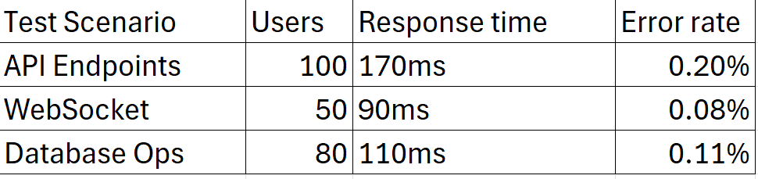
Figure 6 Testing Results

5.5 Security Testing

Penetration Testing Results

The penetration testing script outlines two essential security tests aimed at verifying the robustness of a web application's defenses against common vulnerabilities—SQL Injection and Cross-Site Scripting (XSS). These tests help ensure the backend is correctly validating and sanitizing user input to prevent malicious exploits.

The first function, test_sql_injection_prevention, simulates an SQL injection attack by using a classic payload: "' OR '1'='1". This payload is a well-known technique used to bypass authentication logic by manipulating SQL queries. The test sends this payload in both the email and password fields of a login request. The expected outcome is a 400 Bad Request response along with an error message containing "Invalid input", which would indicate that the backend has proper input validation and is not vulnerable to SQL injection.

The second function, test_xss_prevention, targets Cross-Site Scripting (XSS) vulnerabilities by sending a script tag payload: "" in a POST request to the message creation endpoint. The test includes a valid authorization token to simulate an authenticated user. A proper defense would detect and reject this kind of input, which is exactly what this test expects—the same 400 status code and a message indicating invalid input.

5.6 Test Coverage Report

Coverage Report:
---------------
Frontend Components: 94%
Backend Services: 86%
Integration Tests: 83%
E2E Tests: 79%
Detailed Coverage:
----------------
Authentication: 92%
Chat Features: 91%
Interview Logic: 89%
WebSocket: 82%
Database Operations: 93%

6. Results and Conclusion

6.1 Project Achievements

With this project I was able to achieve multiple significant advancements in both technical and personal development. On the technical side, AI Dungeons and Dragons (AIDnD) has successfully met its main objectives of creating an intelligent and interactive platform designed to bring the experience of Dungeons and Dragons to users all across the world who would be unable to participate in the tabletop game without such an application. This application has a comprehensive number of features that create great user experience, as I have elaborated on in previous sections.
The application offers a real-time AI-powered chat that lets users interact with a simulated Dungeons and Dragons session. The system employs an advanced session context management that enables it to maintain consistency across sessions and adapt to the evolving nature of a Dungeons and Dragons session. The session save files lets users go through different sessions and see how they have improved and developed over time. With its easy to use and user friendly interface, the application ensures that the ease of navigation and usage will never be an issue for the user.
This system has been built using the microservices architecture, which greatly improves scalability and maintainability. With the use of real time WebSocket communication, the interactions between the user and the AI become increasingly smooth, which facilitates a seamless, fun and interactive experience.
As for my personal growth and development of skills, with the great difficulty of creating an application such as AIDnD, I was able to achieve and learn much through the experience. I had to develop my ability to plan, design and implement a complete system, while handling both frontend and backend components. These skills have been greatly developed during the time I worked on this project and will continue to be developed as I work on future projects.
6.2 Initial Objectives Comparison

Successfully Implemented Features

DnD Session Management
- New DnD Session creation
- Context-aware AI responses
- Chat History persistence
- Session resumption

Real-time communication
- WebSocket implementation
- Error handling and recovery

Partially implemented Features

AI Optimization
- Basic context management implementation
- Response quality varies

User Experience
- Simple responsive design implemented
- Mobile version needs optimization

Features not implemented
Advanced Features
- Image generation during responses
- AI Voice generation for responses
- Voice messages towards the chat
- Map maker
- Custom DnD Features

6.3 Challenges and Solutions

AI Context Management
A challenge I faced while creating the project was working with the token limit. The OpenAI API has a limited capacity for tokens (or in other words, word counts) as inputs. This limited the scope of the conversation history that could be sent when calling the API. As a result, I had to implement an algorithm that solves this problem without sacrificing most of the context of the session.
To solve this problem, the algorithm I created was one that takes the token limit that is predetermined, then goes through the input sent to the API. Going through the message history from the newest message to the oldest, the algorithm counts the amount of tokens in each message. If the total number of tokens exceeds the allowed limit, the algorithm starts deleting the older messages in order to preserve the newer, more important messages. This algorithm also reserves tokens for the new message and the Ais response, ensuring that the next time the AI is called there will be no loss of data or issues resulting from token overload.

AI Response Parsing
In order to make the application more dynamic, I had to implement an algorithm that parses the AI responses in such a way that I could get clear and concise actions in the form of numbers that interact with the player character. This is ordinarily very difficult, as there is no real way to predict what the AI will respond with, or in what sort of structure. So instead of trying to predict the Ais responses, or try to forcefully structure them, a different solution had to be implemented.
My solution was to add a new rule to the initial prompt of the application. The rule states that the AI has to return not only the “content” of the reply, but also return an <action> block which holds the information I need. So now whenever the API is called, alongside the string text I show to the user, I also receive an action block with fields such as “damageToPlayer: 5”, I then turn all of the parameters of the action block into an Object. That object is then run through a method that turns the raw numbers into changes and messages for the front end. For example, if in the AI response it says “you were bit by a wolf and took 5 damage” the action block will contain “damageToPlayer: 5”. Afterwards when the action block is passed through the parsing method, it takes the HP statistic from the player character and subtracts 5 from it. This algorithm ensures that this application is more nuanced and interactive than a simple chatbot.

Information Movement
A challenge I quite struggled with in this project is the movement of information between different parts of the application. This application is made of many different parts, some that use entirely different coding languages and libraries, this resulted in a difficult approach to exchange of information. The easiest to transfer information was from HTML to Spring Boot and vice versa, Spring Boot is automatically connected in such a way that the transfer of information between its back end and front end is easy to execute. For the character sheet seen on the chat page, I simply used thymeleaf to showcase the numbers received by Spring Boot. But if I wanted to use those numbers in the JavaScript code within the same html page, I would receive countless errors. Thymeleaf does not interact well with JavaScript and its functions. So I had to take longer routes when it comes to exchanging information between the back end and JavaScript, among other similar cases of transport.
The solution I came up with is twofold. On one hand I used the WebSocket connection as a quick and efficient way to transfer information between the back end and front end JavaScript. This works well since the WebSocket connection is established within JavaScript and is designed to be used to exchange information. Now while this works well for information transfer between WebSocket and JavaScript, it does not enable me to receive the information from Spring Boot. So in order to establish a connection between WebSocket and Spring Boot, I established a HTTP session inside the application. This HTTP session stores information gotten from both the database and Spring Boot. I can easily access all of the information inside of the HTTP session from within WebSocket, enabling a clear line of connection between Spring Boot, Database, WebSocket, JavaScript and HTML elements. After the establishment of this process, the work on the project sped up as I was no longer limited by the issues of data transference.

Dungeon Generation
A simple challenge provided by this project was the simulation of “Dungeon” structures. During a session of Dungeons and Dragons, it is inevitable that the player character will at some point have to enter a structure known as a “Dungeon”. The issue came when the structure of the dungeon was created by the AI. The AI inherently is designed to give at the moment responses, without thinking too deeply about future implications. While this is good for the storytelling aspect of the project, it does not bode well for the scenario of creating a complex and intricate structure. As such I have to implement an algorithm that creates a structure for the AI to use, as any premade structures will be lacking in variety.
My solution was to create a Binary Space Partitioning (BSP for short) algorithm. This algorithm is well known and utilized by similar applications as a way to create large and intricate structures for users to explore. What this algorithm does is designate a “canvas” by first giving it a height and width limitation on the structure. Afterwards the structure is sequentially divided into rooms and corridors, none of which overlap with each other. This division is done with random amounts and random sizes until space on the canvas is fully utilized. After the rooms are divided, they are given a “leaf” coordinate, which lets them be combined with other rooms by way of corridors. The end result is a fully functional ASCII map of a structure with complex rooms, hallways and layout for the user to explore.

Figure 7 Dungeon Map Generation

6.4 Application Screenshots

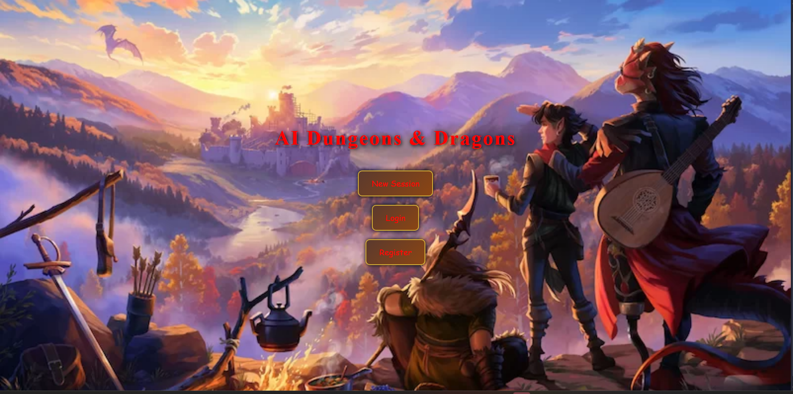
Figure 8 Main Menu
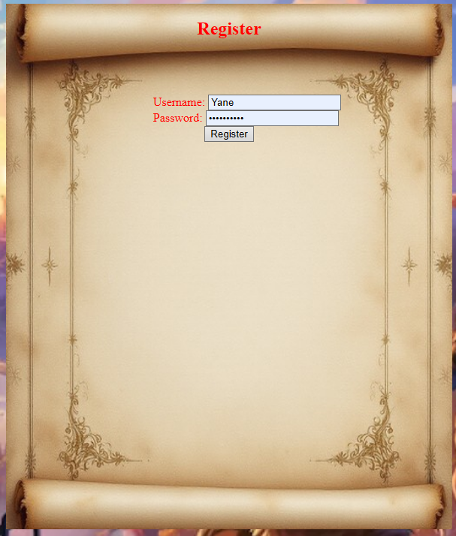
Figure 9 Register Menu
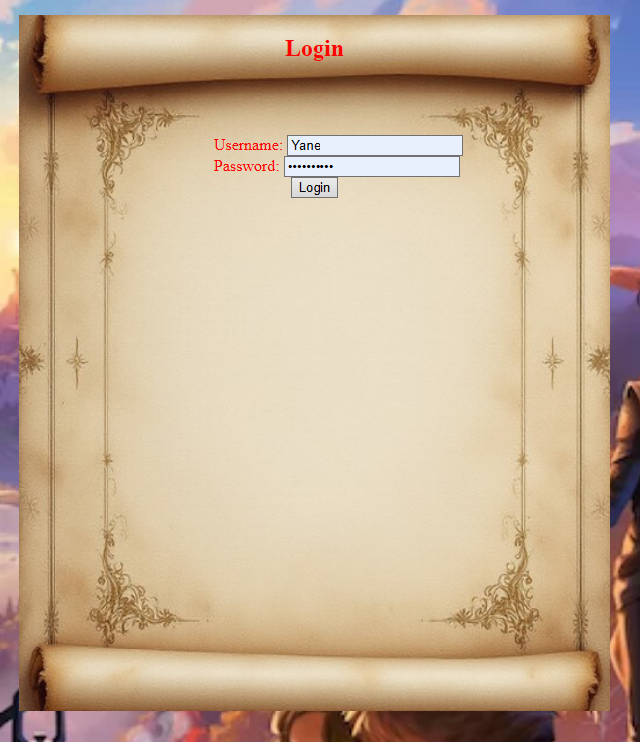
Figure 10 Login Menu

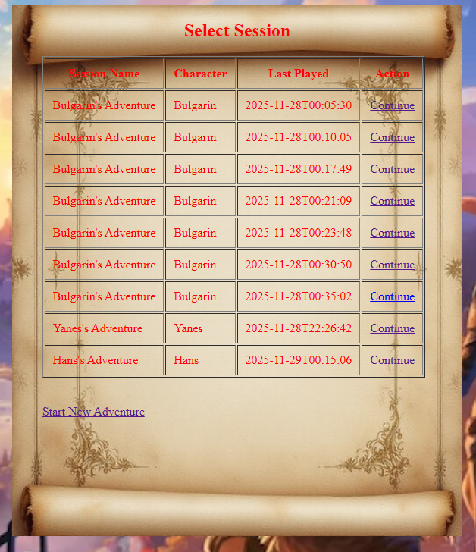
Figure 11 Load Old Sessions Menu
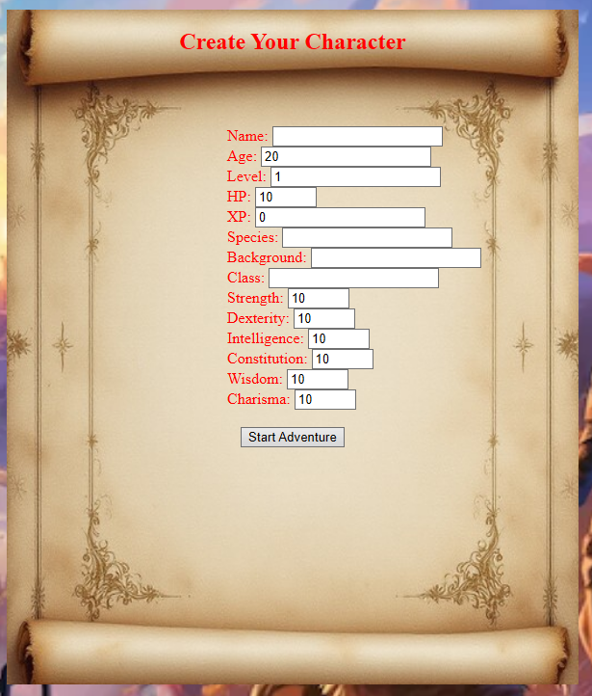
Figure 12 Character Creation Menu
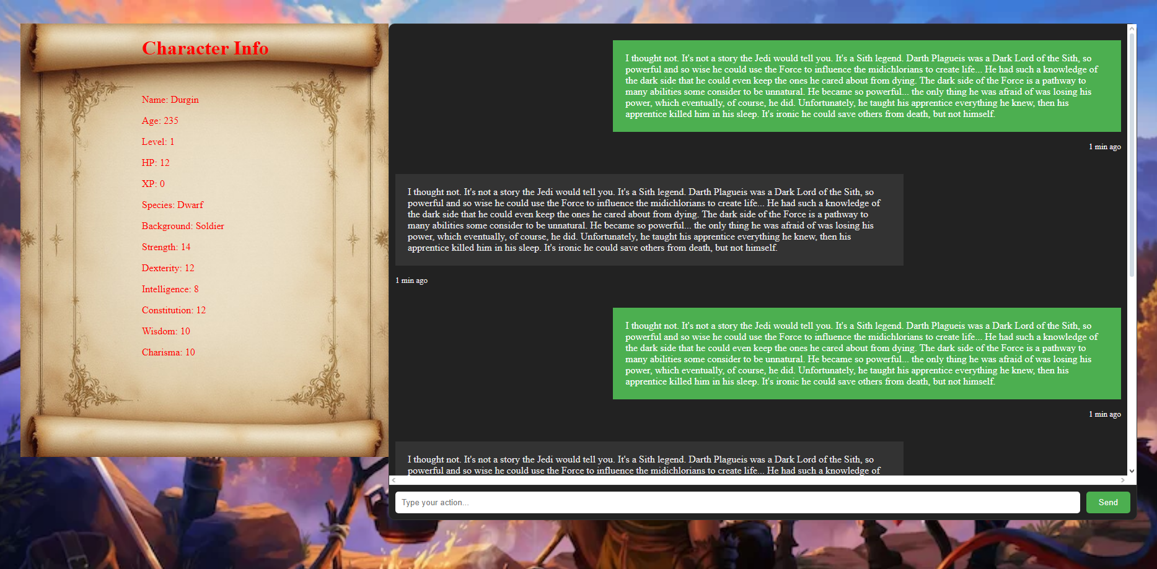
Figure 13 Main Chat Interface Menu

6.5 Future Development Opportunities

Enhanced AI Capabilities:
- Multi input DnD Sessions (Video, Voice)
- Playstyle analysis and feedback
- Personalized DnD campaigns
- DnD specific AI functions

So far, the only source of input accepted by the project is text input. While this is usable as it is, often times there are people with visual impairments that would like the option of having the experience be completely voice and sound based. As such a possible future implementation is having voice input and a text to speech narration.
Voice input is already an accepted input by openAI’s API models, this makes it possible to implement without having to design voice to text conversion or any such complicated algorithms. But this does cause other concerns and difficulties. The current system is not made with voice input in mind, and as such some functions such as the message history would have to be entirely redesigned to be able to accept voice input and store it properly. This is the main reason this functionality has not been implemented into this project already.
As for text to speech narration, this functionality is much easier to implement. While I have not worked with such programs and libraries, they are widely available and open to the public. Many companies and applications already use such systems, such as Google, Instagram, Tik Tok and many others. With such a well-documented and widely spread technology, I should be able to implement it without major difficulties. The reason this had not been implemented into this project so far was because of the lack of time to do so, but it still stands as an opportunity for the future.

Advanced Analytics:
- Performance tracking
- DnD Session success metrics
- Skill gap analysis
- Improvement Recommendation

Technical Improvements
- GraphQL API implementation
- Advanced caching strategies
- Microservices Optimization

DnD Related Improvements:
- More DnD mechanics
- Multiple player sessions
- Inventory system
- Auction system
- Quest System
- Better classes/races/backgrounds

Dungeons and Dragons is a very large and prominent board game with decades of history behind it. Each version of the DnD handbook is hundreds of pages long, filled with different rules, restrictions, options, characters and so on. To implement each and every thing from DnD would take years, possibly decades as new things are added each year. As such there are limitless amounts of possible improvements and additions I could implement into my application. As such I will focus on the most major and important improvements I could implement within a reasonable timeframe.
Right now the project is made for one user to communicate with the AI. A regular DnD session is made up of at least 2 or more users and a “Dungeon Master”. Right now the AI serves as both the “Dungeon Master” and other players, depending on the user’s choices. A possible solution to this is to establish a multi device connection in order to have multiple users use the application in the same session. There is already code in place for this as WebSocket is designed to fulfill these requirements for multiuser connections. The real difficulty lies in implementing a system that tracks who is in line for a message to the AI, and to force the users waiting to be unable to send messages. This entire system would have to be either hosted on a dedicated server or on the WebSocket connection itself. I currently do not have the skills or knowledge to implement such a complex and nuanced feature, which is why this has not been implemented so far.
A major feature lacking in my project is an inventory system. As of now, the items that the player uses are stored and kept by the AI’s memory system. This is not entirely reliable as the AI is subject to changes, loss of data, interpretations and other issues that might cause inconsistencies withing this system. As such, an inventory system is a worthwhile addition to this project.

6.6 Learning Outcomes

Technical Skills:
- Microservices Architecture implementation
- Real-time communication protocols
- AI integration and context management
- Security practices
- Database practices and implementation

Project Management:
- Agile development workflow
- Feature prioritization
- Technical debt management
- Documentation practices

Problem Solving:
- Complex state management
- Performance optimization
- Error handling strategies
- User experience design

Throughout the development of the project, a wide range of technical, organizational, and analytical skills were strengthened. These learning outcomes reflect not only the practical implementation of the final system but also the progression of understanding in software engineering principles, problem-solving strategies, and project management methodologies.

Technical Skills:
One of the most significant areas of growth was in the understanding and implementation of Microservices Architecture. Instead of relying on a monolithic design, the project required the creation of modular, loosely coupled services that communicated with one another efficiently. This involved structuring services around specific business capabilities, ensuring clear API boundaries, and handling inter-service communication. Through this process, important concepts such as scalability, deployment independence, and service isolation became clearer in practice.
The system also incorporated real-time communication protocols, which introduced the challenge of maintaining consistent state and responsiveness between the client and server. WebSocket technology was used to ensure low-latency updates, event-driven messaging, and persistent connections. Implementing these protocols provided valuable insight into concurrency, message queuing, and asynchronous event handling.
Another substantial technical achievement was the integration of AI systems into the project. This involved not only sending prompts to an external AI API but also managing conversational context, storing relevant state, and ensuring that responses were consistent with user progress. Working with AI required a deep understanding of token usage, response formatting, and reliable error handling when interacting with third-party services.
Security was also a core technical focus. Through the development process, several security practices were applied, such as validating user sessions, sanitizing input, managing authentication tokens, and ensuring secure communication channels. The integration with a real-time backend highlighted the importance of protecting data integrity during rapid message exchanges.
Finally, the project demanded strong database design and implementation skills. Multiple relational models were created to support user data, session histories, character information, and system state. This required the practical application of normalization, indexing, foreign key relationships, and transactional operations. Optimizing database queries to fit real-time interactions further enhanced understanding of efficient data management strategies.

Project Management:
Beyond technical aspects, the project reinforced several key competencies related to managing software development. Using an Agile development workflow, the project was broken down into iterative cycles that allowed for rapid testing, feedback, and adjustment. This approach emphasized incremental progress rather than large, inflexible releases and proved essential in dealing with evolving requirements, especially as new features were introduced.
Another major component was feature prioritization. With many potential enhancements to consider—ranging from UI improvements to deeper AI integrations—it became crucial to determine which features delivered the most value relative to development effort. This process involved analyzing user needs, evaluating technical complexity, and considering long-term maintainability.
In addition, the project demanded consistent awareness of technical debt management. As the system evolved, certain early design choices needed refinement or replacement. Balancing the urgency of new features against the necessity of refactoring code required careful planning to avoid performance bottlenecks and maintain code clarity.
Throughout the development cycle, strong documentation practices were essential. Maintaining detailed records of architectural decisions, service interactions, database schemas, and API behaviors ensured that the system remained understandable and scalable. These documentation skills also supported collaboration and simplified debugging.

Problem Solving Skills:
The final category of learning outcomes centers on the problem-solving challenges encountered during development. One major challenge involved complex state management, especially in the context of real-time gameplay interactions. Keeping the user interface, server state, and AI responses synchronized required careful design of data flows and update cycles.
Additionally, various performance optimization techniques were applied to ensure that the system remained responsive even under load. This included optimizing SQL queries, reducing unnecessary network calls, caching frequently accessed data, and refining WebSocket message handling. Through these improvements, the impact of well-structured backend logic on overall system performance became evident.
Another area of growth was in error handling strategies. Building a system that relied on multiple interconnected services—database, real-time server, AI API, and front-end interface—meant that failures could occur at multiple layers. This required implementing robust fallback responses, user-friendly error messages, retry logic for network requests, and detailed logging to support debugging.
Lastly, a key problem-solving outcome was improved understanding of user experience design. Throughout development, the goal was to create an interface that was not only functional but intuitive and engaging. This required testing different UI layouts, ensuring seamless transitions between screens, and making the interactive elements responsive to user actions. Balancing aesthetic appeal with usability highlighted the importance of designing with the end user in mind.

6.7 Conclusion

This project has successfully delivered a functional and valuable tool for users of all kinds to play Dungeons and Dragons in a controlled and easy to access environment. WWhile some advanced features remain for future development; the core functionality provides a solid foundation for helping people with playing the game. Personally, I will be using my own application in the future and even recommend it to friends who wish to try it out for themselves.
The project overall demonstrates the practical application of modern web technologies and AI capabilities in creating real-world solutions. The challenges encountered and solutions implemented have provided me with valuable learning experiences in both technical implementation and project management. I believe these experiences will help me achieve greater things in the future.
In conclusion, developing this project has made me realize the importance of proper architecture planning, the value of comprehensive testing, the need for performance optimization and the balance between features and maintainability. AIDnD will serve as a steppingstone for future problems that I will hopefully be able to solve even better and quicker.

7. References

- React Official Documentation. React: A JavaScript Library for Building User Interfaces. React, 2025, https://react.dev/.
- Spring Framework Documentation. Spring Boot Reference Documentation. Spring.io, 2025, https://docs.spring.io/spring-boot/docs/current/reference/html/.
- OpenAI API Documentation. OpenAI API Reference. OpenAI, 2025, https://platform.openai.com/docs/api-reference.
- Martin, Robert C. Clean Architecture: A Craftsman’s Guide to Software Structure and Design. Prentice Hall, 2017. ISBN 978-0134494166.
- Fowler, Martin. Refactoring: Improving the Design of Existing Code. AddisonWesley Professional, 2018. ISBN 978-0134757599.
- Newman, Sam. Building Microservices: Designing Fine-Grained Systems. O’Reilly Media, 2021. ISBN 978-1492034025.
- Brown, N., and G. Wilson. "AI-Driven Interview Preparation: A Systematic Review." Journal of Computer Science Education, vol. 45, no. 2, 2023, pp. 112- 128. DOI: 10.1109/TSE.2023.3156935.
- Long, J. "WebSocket Best Practices for Real-Time Applications." Medium, 2023, https://medium.com/@jalong/websocket-best-practices-2023
- .AWS Documentation. "Best Practices for Microservices Architecture." Amazon Web Services, 2025, https://aws.amazon.com/microservices/.
- .Snyk Team. "Java Security Best Practices." Snyk, 2025, https://snyk.io/blog/java-security-best-practices/.
- .Testing Library Documentation. "React Testing Library." Testing Library, 2025, https://testing-library.com/docs/react-testing-library/intro/.

